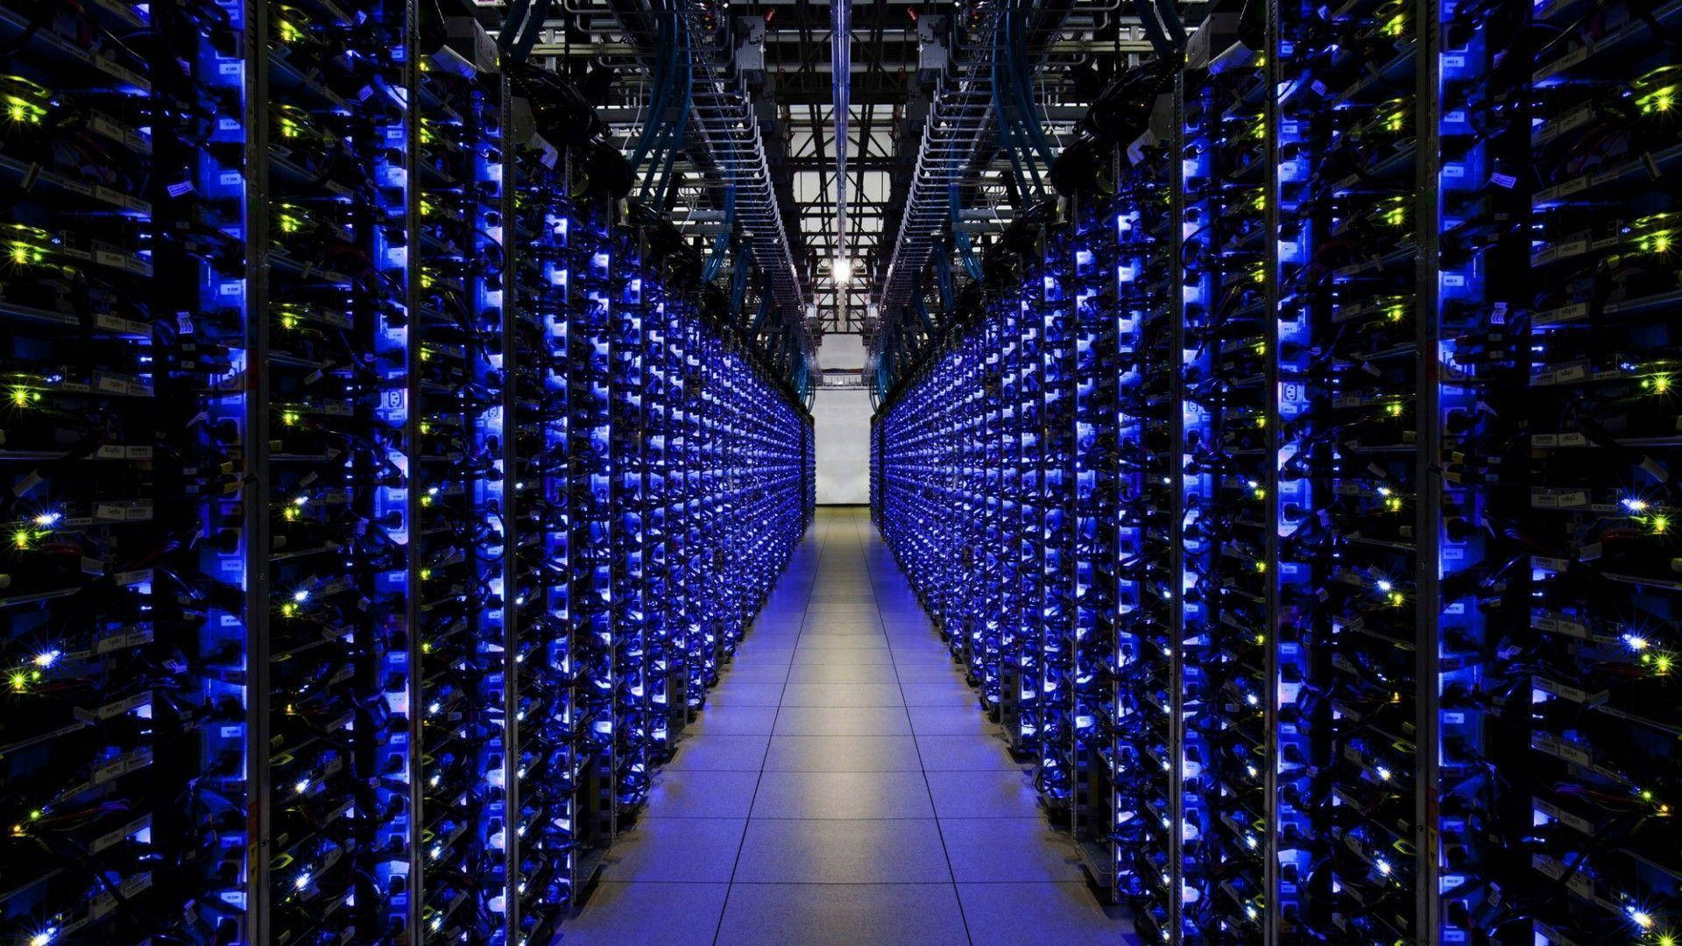

Miguel Sánchez Rodríguez

Miguel Sánchez

Pablo Ruiz Morán

Jaime Alvarado Fernandez

MODELO DE DOMINIO



